1. Freeze



This simple game can be a great family activity that will enjoy.

**What You Will Need**

* Music
* Space to play

**How to Play**

* Play the music and dance till the music stops and ask everyone to freeze in the position they were in.

**Suggestion**

You can even ask the kids to pose in specific postures to make the game challenging.

1. Musical Chairs

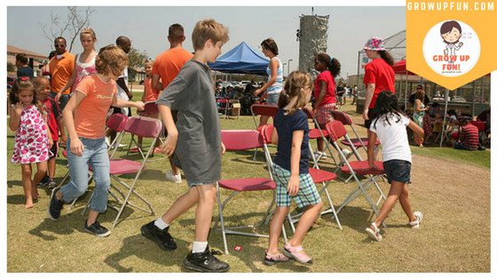

This is a game for whole family.

**What You Will Need**

* Music
* Chairs

**How to Play**

* Place chairs (1 less than the total number of players) in a circle
* Play music and ask the players to dance around the chairs
* When the music stops, they will need to sit on the closest chair. The person without a chair is out of the game. This chair and[music game](https://parenting.firstcry.com/articles/15-interactive-music-games-for-kids/?ref=interlink) is very much fun.

**Suggestion**

You can ask the players to run around the chair to make it more challenging.

1. Guess the Person



This is a pure guessing game and can be played by the whole family.

**What You Will Need**

* A piece of paper to write the names on

**How to Play**

* Your kids will write a name of a family member, friend or teacher on the paper and keep it with him
* You will need to guess the right name of the person

**Suggestion**

This game can be more interesting by giving clues about the person.

4.Carom

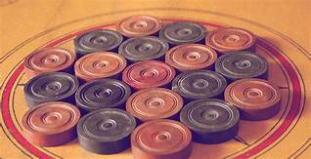

This four-player game is perfect for some family time.

**What You Will Need**

* Carom board, coins

**How to Play**

* Aiming a striker, you will need to hit the other coins into the pockets on the corner of the board
* Different coloured coins have a different value, and the rules may differ across the region

**Suggestion**

Make the game competitive by playing in teams.

5.Snakes and Ladder

Snakes and ladder is a classic family game that can be enjoyed by everyone.

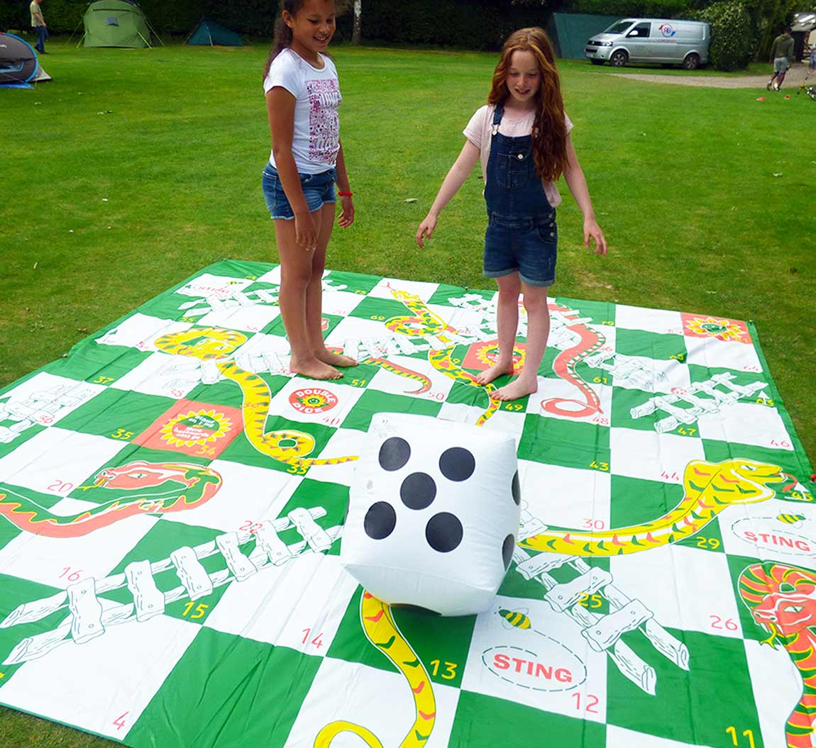

**What You Will Need**

* The snake and ladder board game with dice and coins

**How to Play**

* Each person gets to roll the dice and move as many spaces as the number on the dice
* If you reach a ladder, you climb up, and if you fall on the mouth of a snake, you will need to drop down to the tail

**Suggestion**

Play this game with three or four players for the best time.